LSTM-Based Jamming Detection and Forecasting Model Using Transport and Application Layer Parameters in Wi-Fi Based IoT Systems
IoT (internet of devices) is mostly preferred because of high speed wireless communication but this devices often suffered with various attacks such as DOS or Jamming. Jamming attack can be done in random or constant time where constant refers to attack regularly and random means jamming will occur at random times. If there is more delay in receiving response that also consider as jamming attack.
In propose paper to detect such attack author employing deep learning based LSTM algorithm which can detect jamming attack with an accuracy of over 99.50%. Propose paper presents a novel technique to detect jamming in IoT, focusing on communication and environmental dynamics in industrial settings. To better examine the communication conditions and jamming in the industrial production environment, it initially focuses on collecting quality of service (QoS) and connection parameters during normal communication and jamming attacks in production lines equipped with wireless IoT devices with server-client architecture. Experimental findings demonstrate the strikingly profound impact of spot jamming on the upper layers of the protocol stack, revealing that jamming attacks on the physical layer can trigger cascading failures at the transport and application layers.
To detect IoT Wi-Fi jamming attack author has built his own dataset and then employed different machine and deep learning algorithms to train a model and this models applied on test data to calculate prediction accuracy. Author has used SVM, CNN, Random Forest, KMEANS and LSTM and among all algorithms LSTM is giving best accuracy. Each algorithm performance is evaluated in terms of precision, recall, FSCORE and accuracy.
In propose paper author used two LSTM layers and one dense layer to achieve 99% accuracy and we designed same layers with LSTM.
Author has not publish dataset so we have used IOT jamming attack dataset which is available on net and this dataset can be downloaded from below URL
https://www.kaggle.com/datasets/daniaherzalla/radio-frequency-jamming
Above dataset contains different files for Normal and Jamming attacks and can download from above URL
Extension Concept
In this extension we have experimented with CNN2D algorithm which will trained and optimize features using 2 dimension neurons. Filtering features using CNN2D layer can help algorithm to get more optimize features which help in better prediction accuracy. CNN2D is giving 100% accuracy on 20% test data.
SCREEN SHOTS
We have coded this project using JUPYTER notebook and below are the code and output screens with blue colour comments
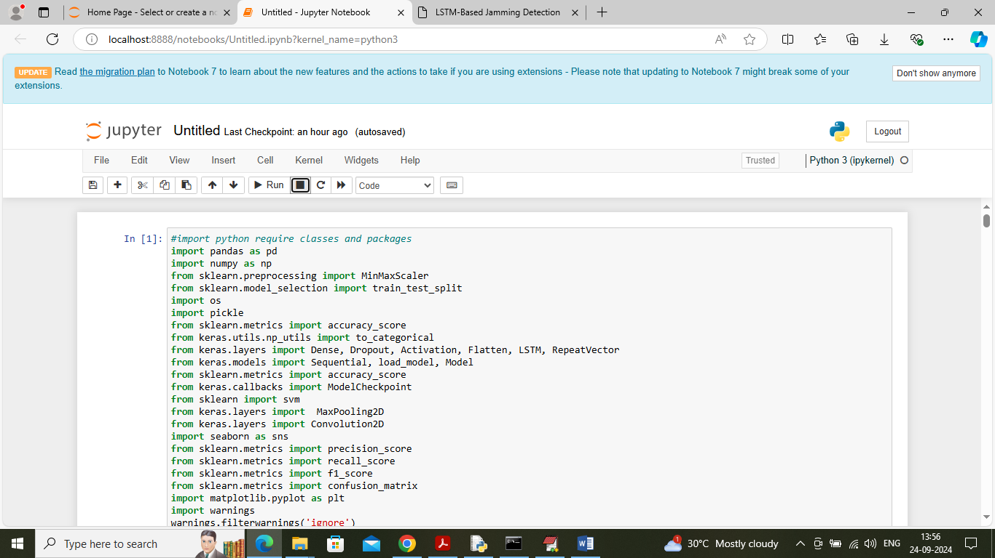
In above screen importing required python classes and packages
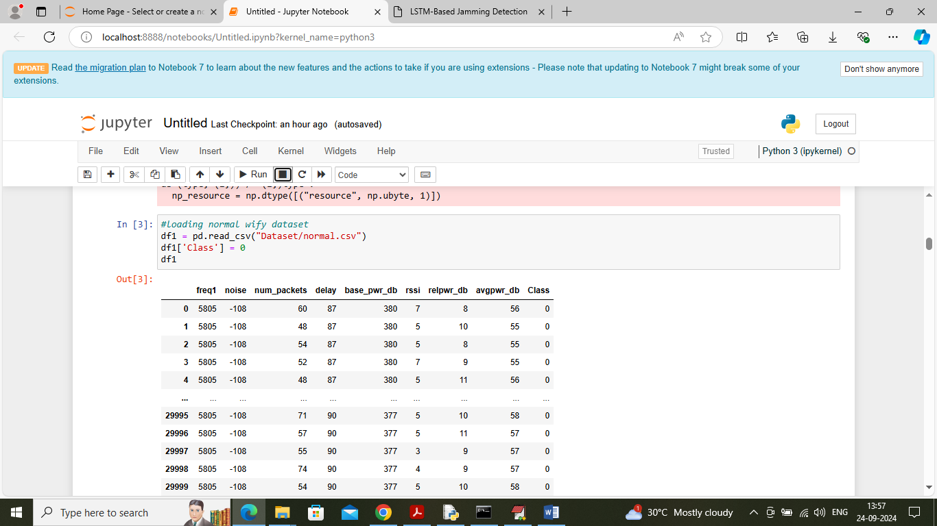
In above screen loading and displaying Normal WIFY connection dataset
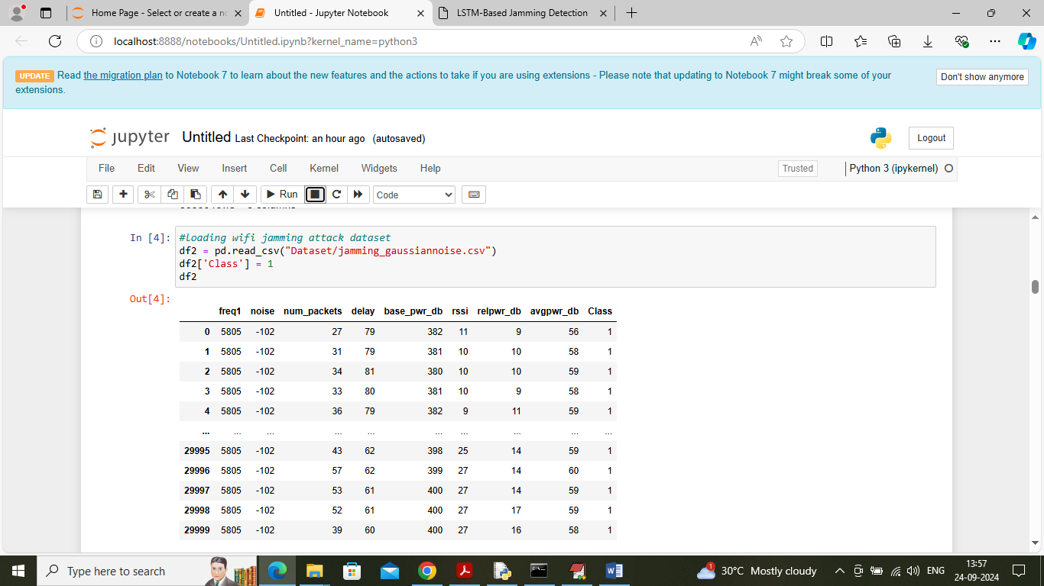
In above screen loading and displaying jamming dataset
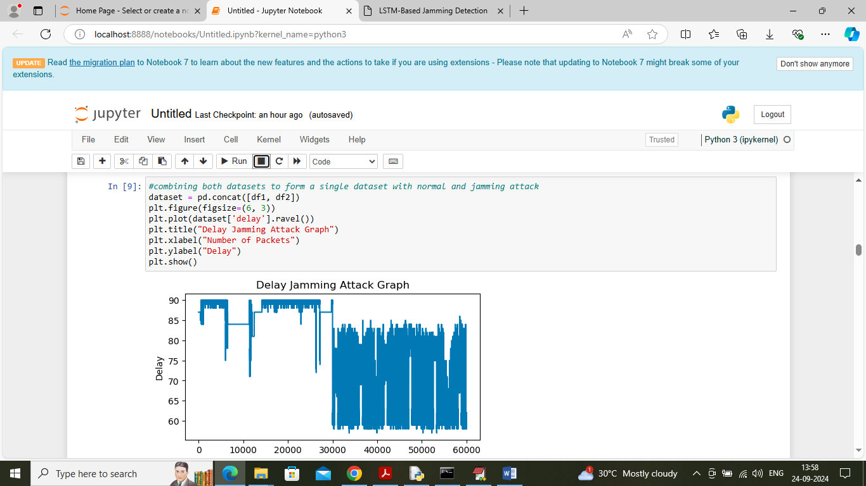
In above screen merging normal and jamming dataset and then plotting graph of delay. Highest delay will consider presence of jamming and in above graph x-axis represents ‘Number of records’ and y-axis represents delay
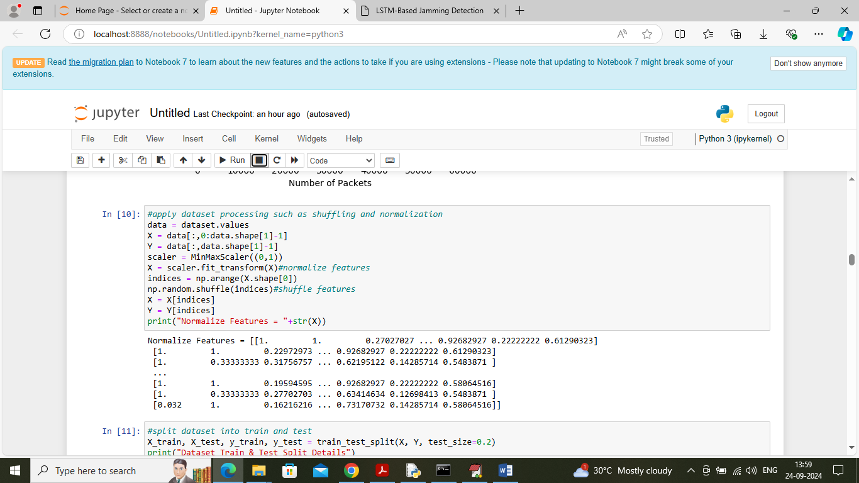
In above screen applying dataset processing techniques such as shuffling and normalizing dataset values
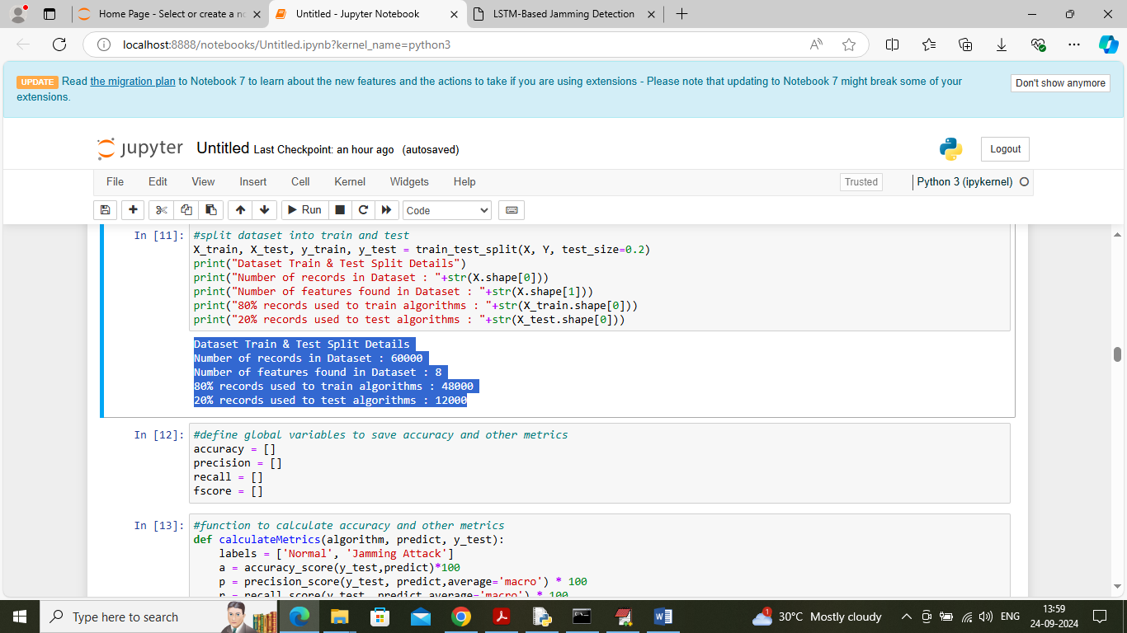
In above screen splitting dataset into train and test where application using 80% dataset for training and 20% for testing and then can see train and test siz
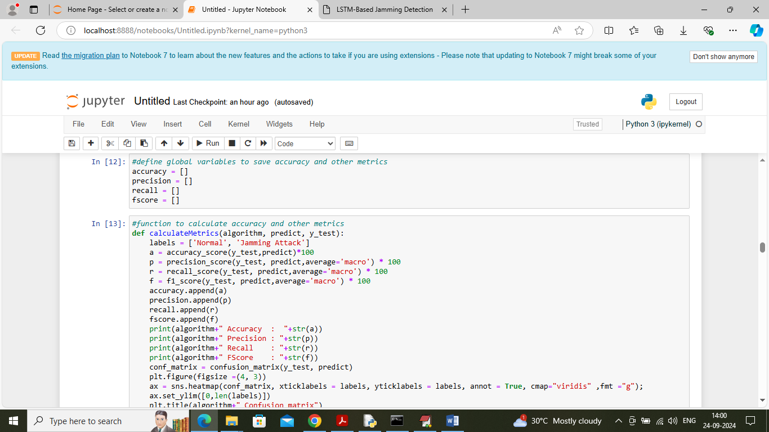
In above screen defining function to calculate accuracy and other metrics
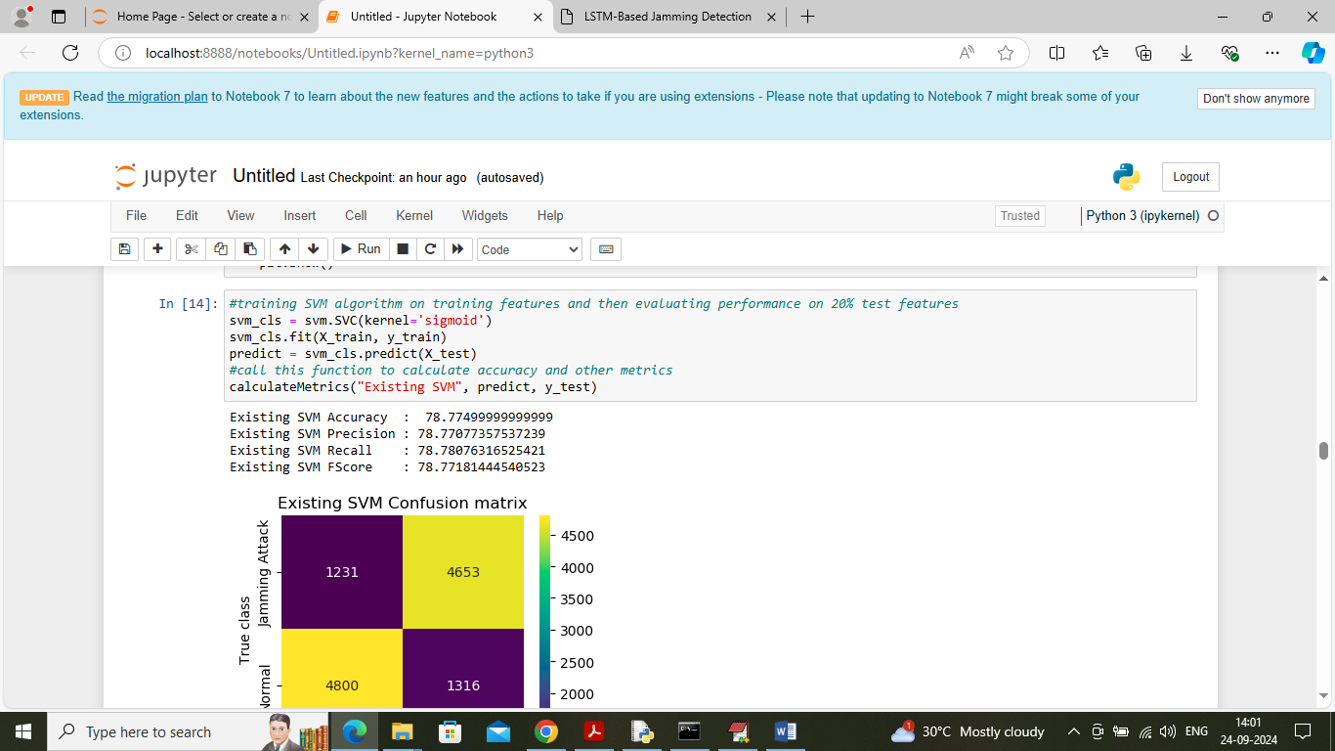
In above screen training existing SVM algorithm on 80% training data and then applying trained model on 20% test data to calculate prediction accuracy. In above screen SVM got 78% accuracy and can see other metrics also. In above confusion matrix graph x-axis represents Predicted Labels and y-axis represents True Labels and then yellow boxes in diagonal represents correct prediction count and remaining blue boxes represents incorrect prediction count which are very few.
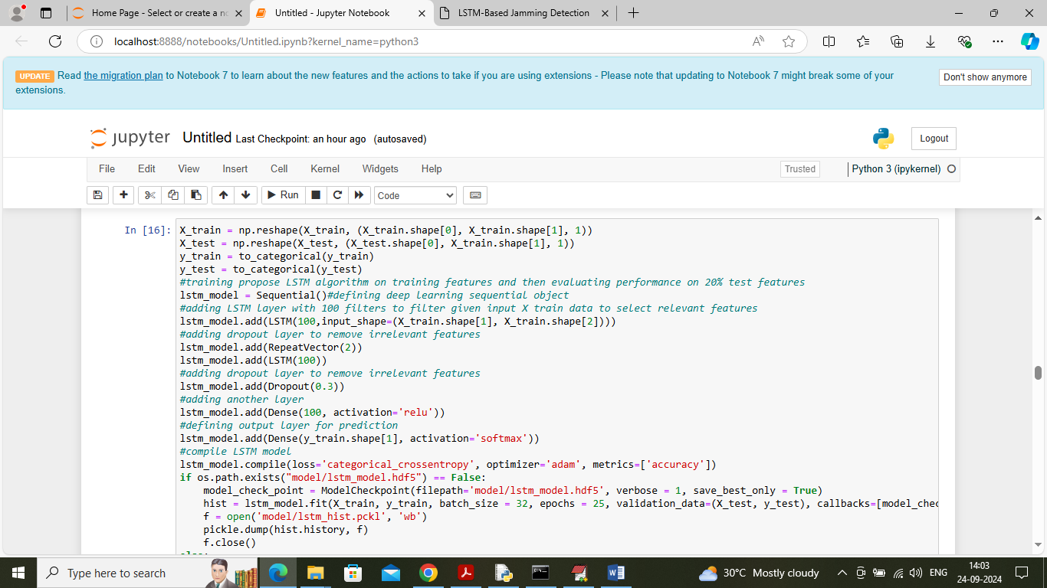
In above screen training propose LSTM algorithm and after executing above block will get below output
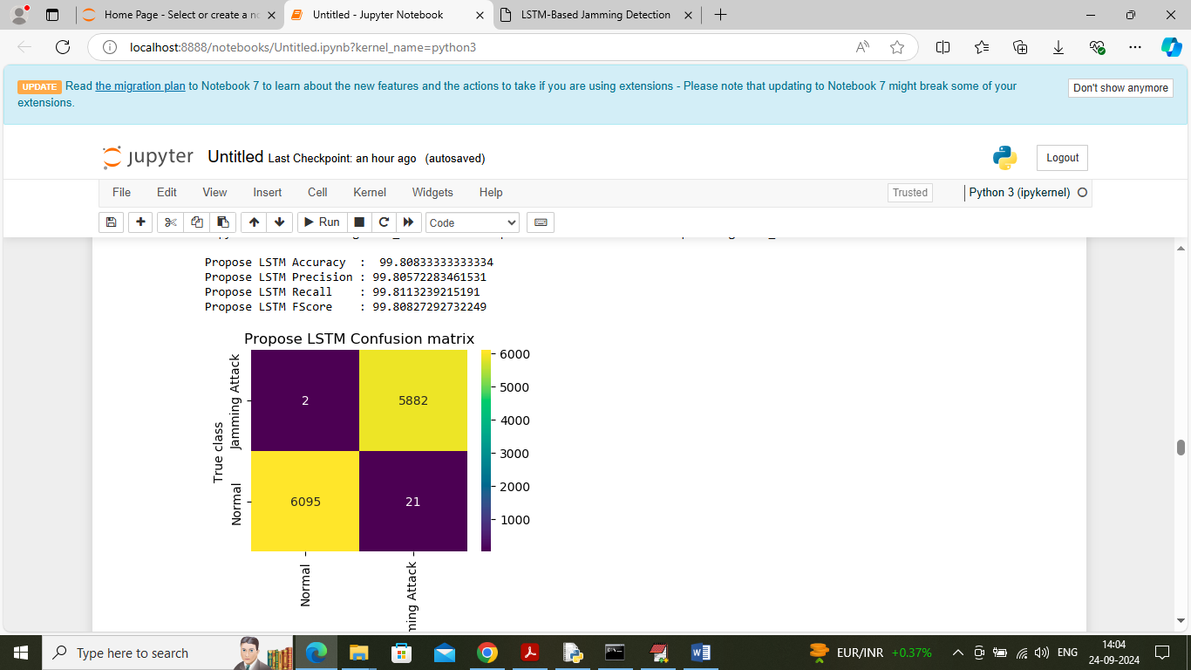
In above screen LSTM got 99.80% accuracy and can see other metrics output also
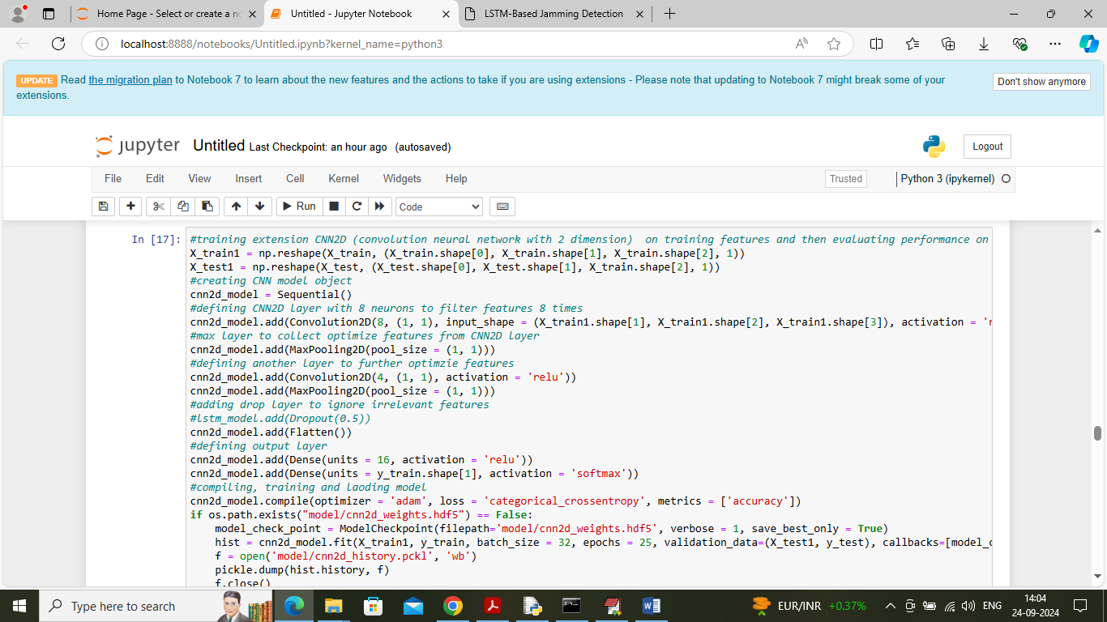
In above screen training extension CNN2D algorithm and after executing above block will get below output
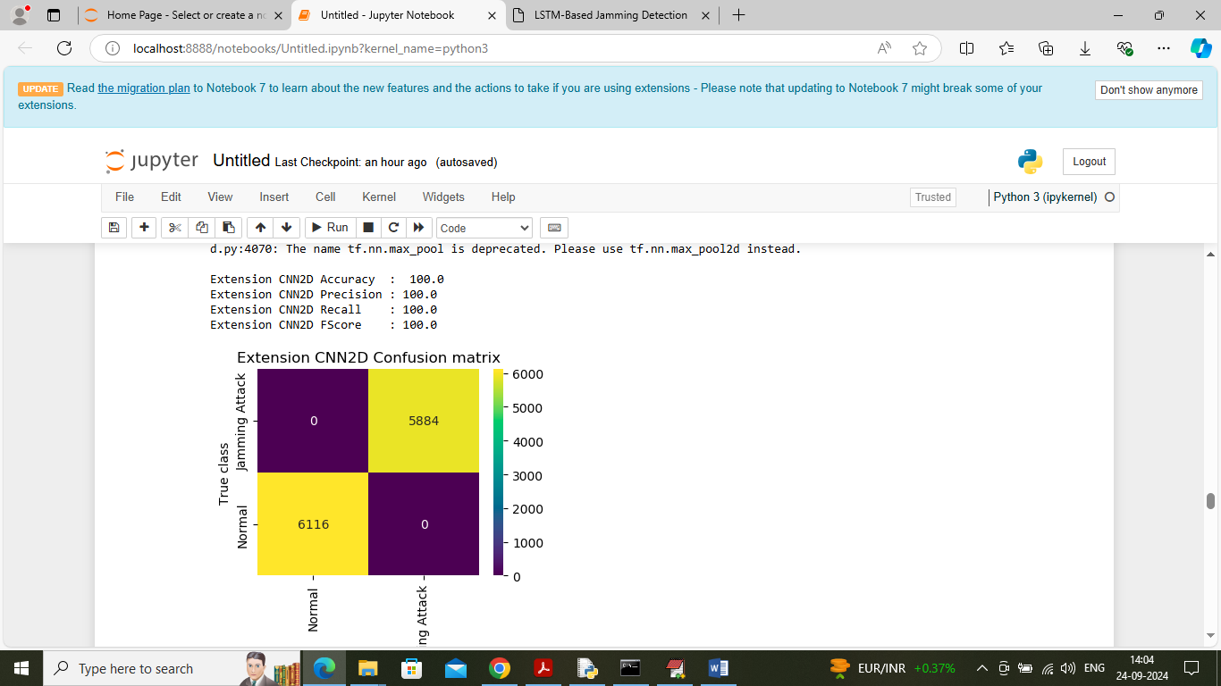
In above screen extension CNN2D got 100% accuracy
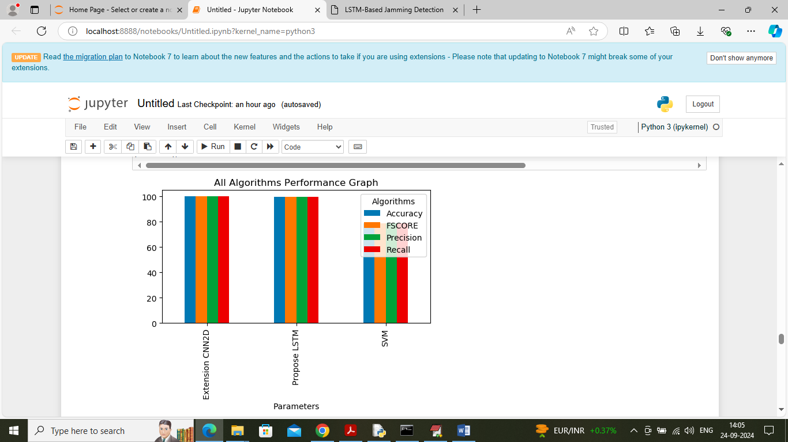
In above screen visualizing graph of all algorithms comparison where x-axis represents algorithm names and y-axis represent accuracy and other metrics in different colour bars and in all algorithms extension got high accuracy
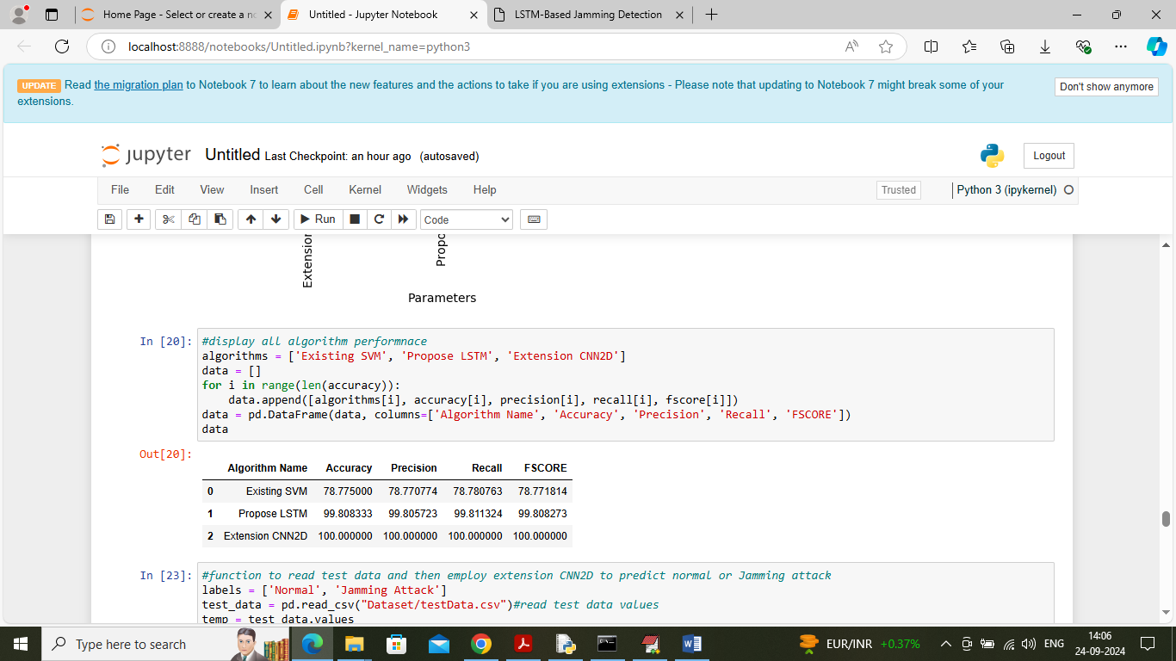
In above screen displaying all algorithms performance in tabular format
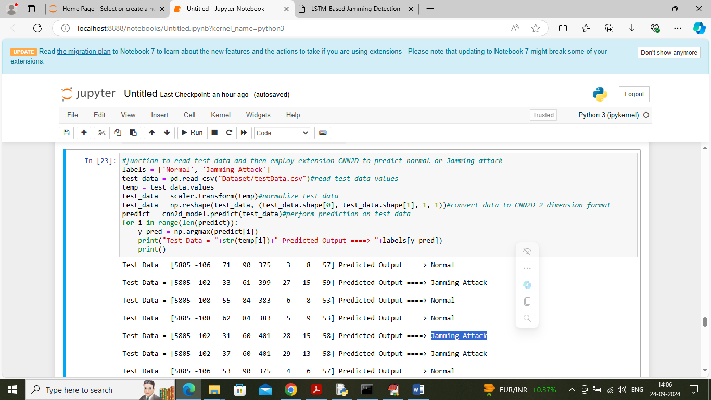
In above screen reading test data values and then applying extension algorithm for prediction and then in output square bracket contains test data values and after = arrow symbol can see predicted Wi-Fi connection is normal or contains jamming attack
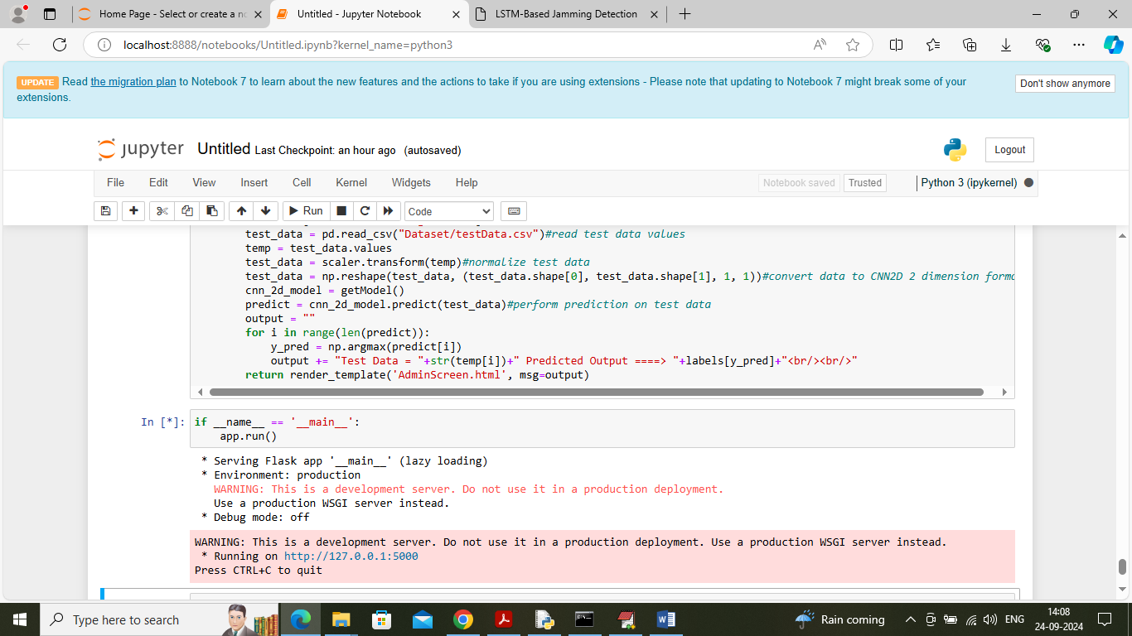
In above screen run all last flask block code to start flask server and then open browser and enter URL as http://127.0.0.1:5000/index and then press enter key to get below page
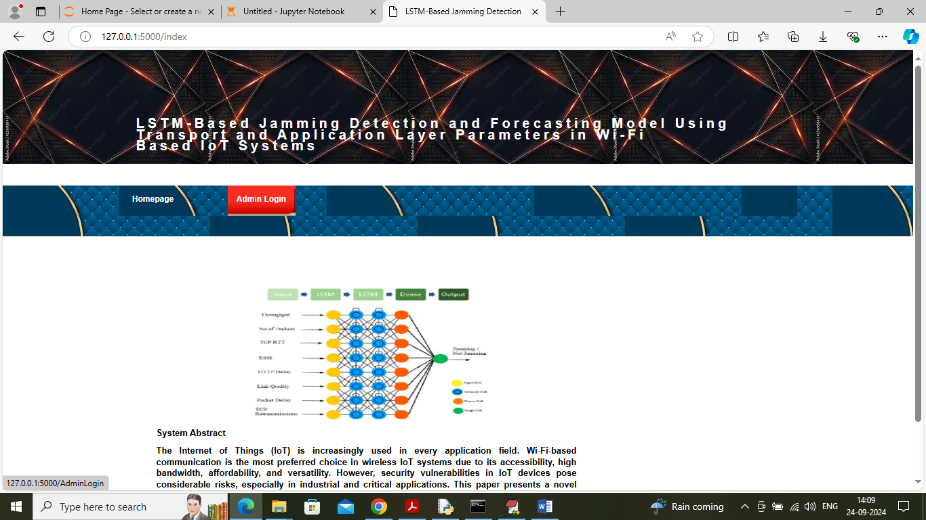
In above screen click on ‘Admin Login’ link to get below page
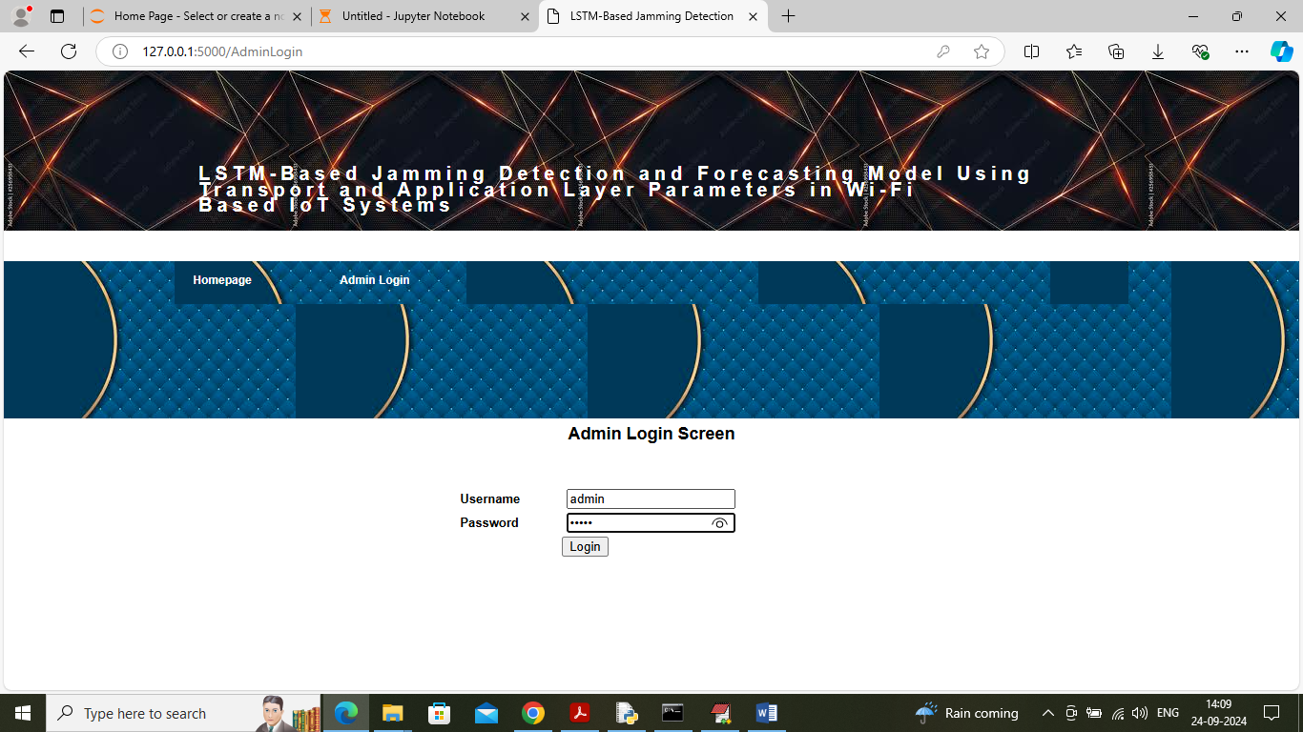
In above screen admin is login and after login will get below page
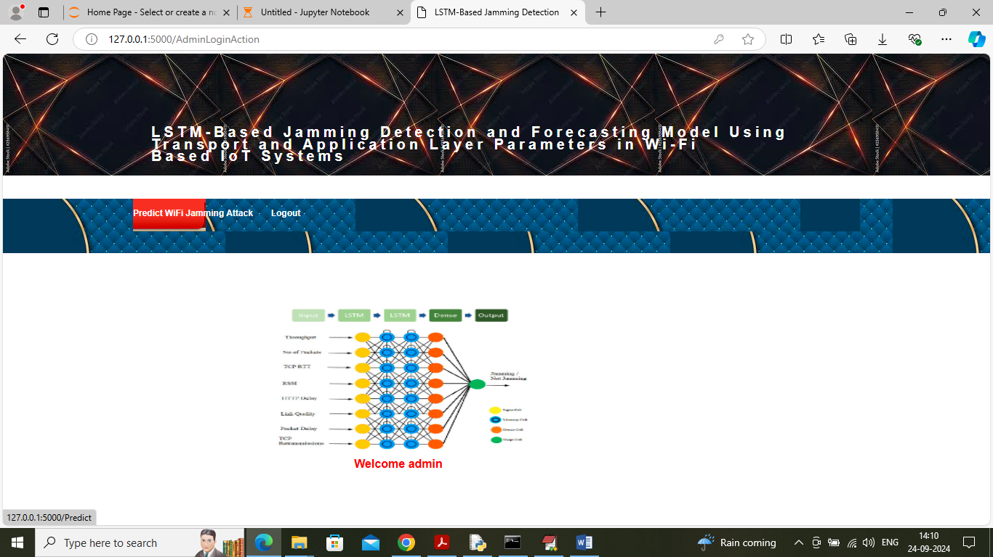
In above screen click on ‘Predict WIFY Jammer’ link to get below page
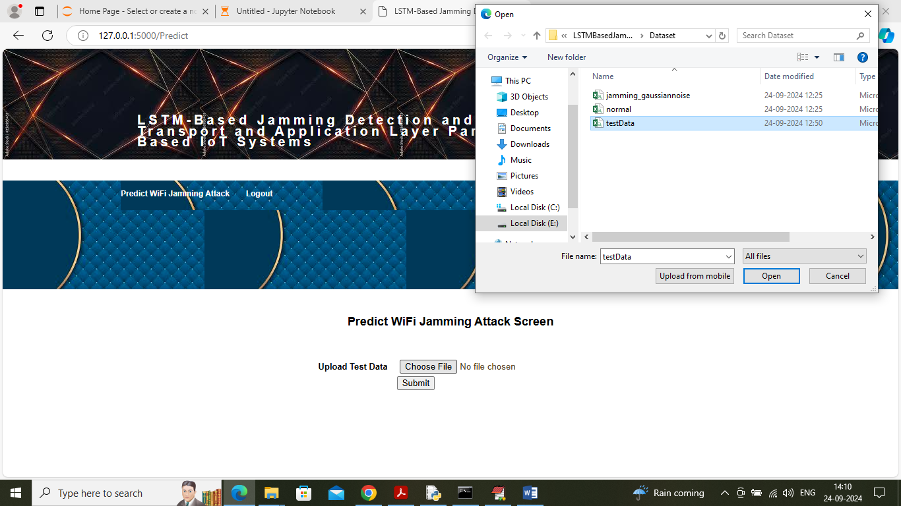
In above screen selecting and uploading test data file and then click on ‘Open’ button to get below output
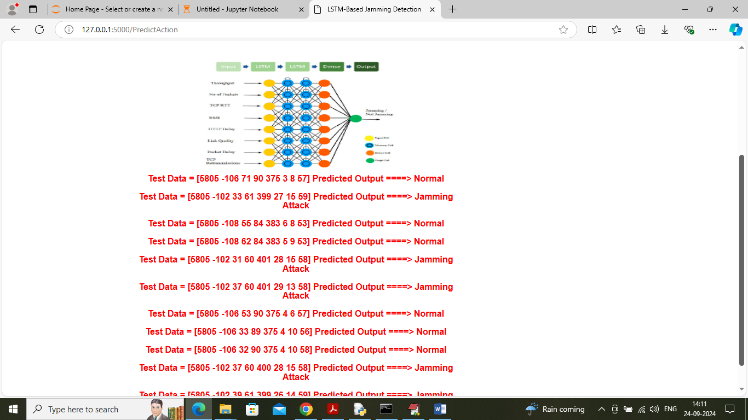
In above screen in square bracket can see test WIFI signal values and after = symbol can see predicted output

